**IBM WATSON IOT CREATION**

Team Id : PNT2022TMID31048

Project Title : Personal Assistance For Seniors Who Are Self-Reliant

IBM WATSON IOT & DEVICE CREATION

STEP 1: CLICK ON CATALOG

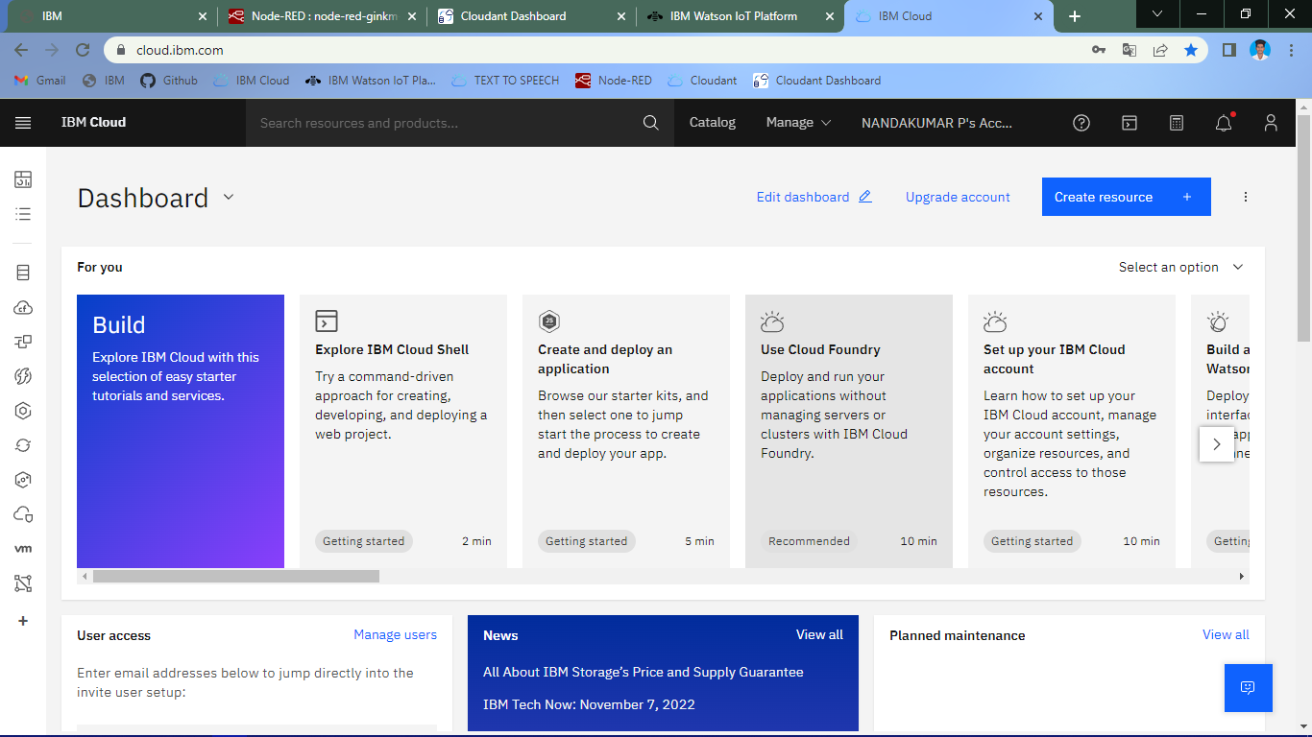

STEP 2 : GO TO IOT PLATFORM

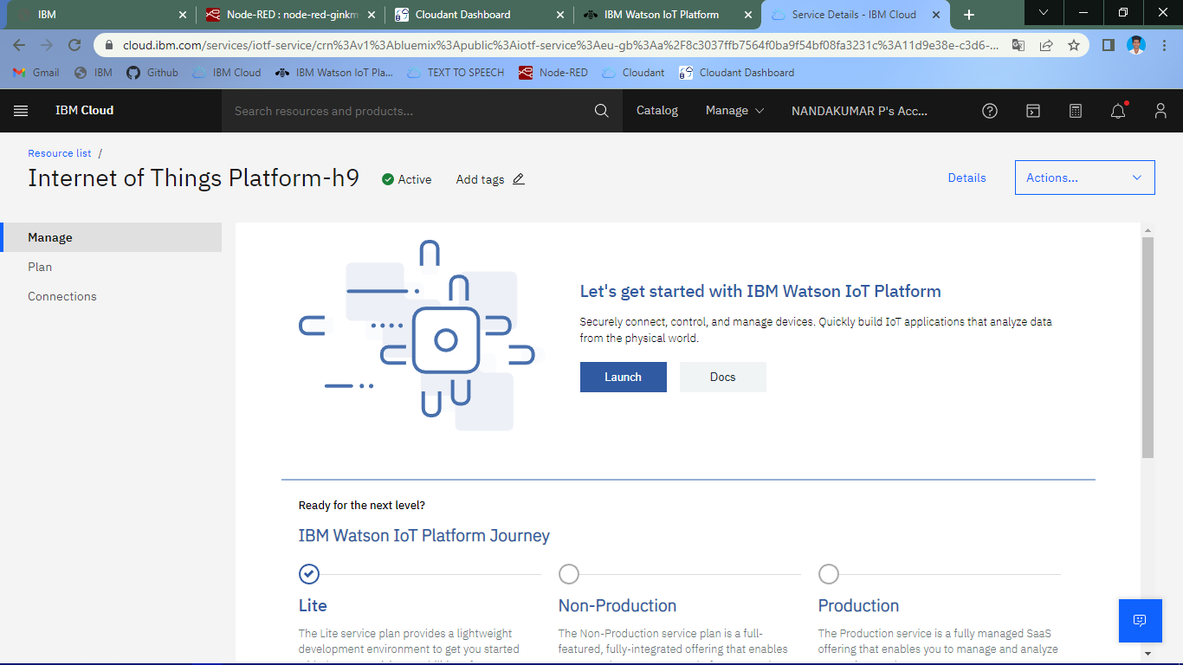

STEP 3 : SIGN IN USING IBM ID AND PASSWORD

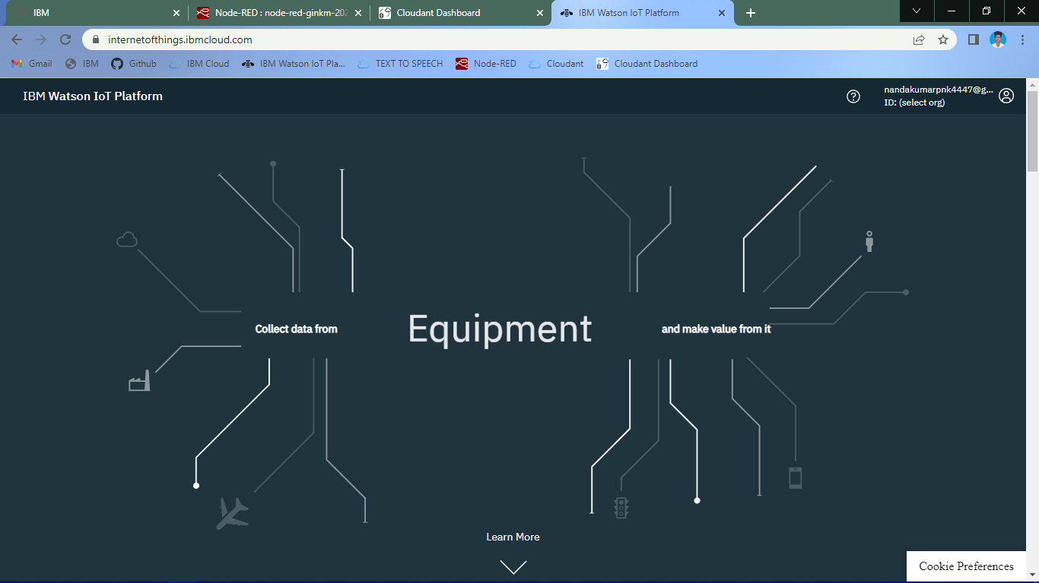

STEP 4 : CREATE THE DEVICE

